LEVEL 2 FLOOR (1)
Handstand (for walkover, handspring and flic flac) | 1. Angry Cat Drill Revision – hold 30 secs
 | 2. Lying on stomach with hands against a wall – looking at hands, covering ears – chest in, bottom squeezed – hold 30 secs
 | 3. Handstand with nose against wall – looking at hands – covering ears, hips open, bottom squeezed. Push “tall” up the wall – hold 30 secs
 | 4. F2-1.5 Handstand against a wall, with the back to the wall and with the stomach against the wall – when the gymnast can balance well – have them pull their feet slightly away from the wall | 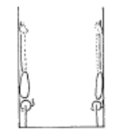 | - arms straight  - chest rounded, extended through the shoulders  - hips open  - gluteal muscles squeezed  - head neutral  - maintain good body tension and alignment  - toes or heels touch the wall only
 | 5. F2-1.3 From stand, take one step, passing through lunge position, place hands on the floor, lift (not kick) the first leg to vertical with the second leg to horizontal
 | 6. F2-1.4 – as F2-1.3 then slowly with control bring the horizontal leg up to join the vertical leg. DO NOT bring the vertical leg down
 | 7. F2-1.7 Handstand walking with assistance | 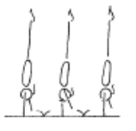 | - arms straight  - chest rounded, extended through the shoulders  - hips open  - gluteal muscles squeezed  - head neutral  - maintain good body tension and alignment
 | 8. ® © Handstand return to stand, fwd roll to “L” sit, reach fwd to pike stretch, candlestick, roll to stand | 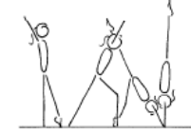 | - fingers spread  - elbows turned in  - chest in and rounded  - head neutral  - shoulders open  - hips open and gluteal muscles squeezed tight  - legs together and locked out  - toes pointed  - body must be vertical with a straight body line
Handstand Fwd Roll | 1. In front of an incline - Coach spots handstand – controlled roll fwd into candlestick position
 | 2. F3-2.2 Walk feet up the wall the near handstand, push off the wall perform a fwd roll onto a soft mat | 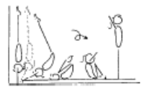 | - maintain good body tension and alignment  - encourage a straight body during the early phase of the fall  - roll in a tight tuck and stand to finish
 | 3. F3-2.1 Handstand in front on an incline, roll onto the incline – arms must be straight | 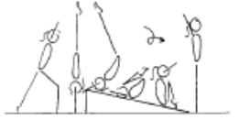 | - maintain good body tension and alignment  - place body off balance then fall  - encourage a straight body during the early phase of the fall  - roll in a tight tuck and stand to finish
 | 4. F3-2.3 Handstand fwd roll on a soft, flat surface (ie supersoft crashmat) | 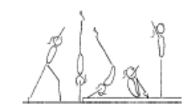 | - maintain good body tension and alignment  - place body off balance then fall  - encourage a straight body during the early phase of the fall  - roll in a tight tuck and stand to finish
 | 5. ®* Handstand fwd roll to L-sit, reach fwd to pike stretch, candlestick, roll to stand

LEVEL 2 FLOOR (2)
Cartwheel / Roundoff | 1. F1-4.5 Side cartwheel along a wall (can be done with back or stomach facing the wall) | 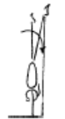 | - maintain good body tension and alignment  - pass through a plie into and out of the skill  - hands parallel, straight arms  - keep body in line bar the mat  - head neutral  - small straddle  - keep arms by ears all through the skill
 | 2. F2-3.4 Have the gymnast perform 2-3 fast side cartwheels in a row, passing through a plie action between cartwheels | 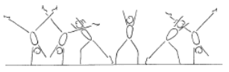 | - keep shoulders and hips square  - pass through plie between cartwheels  - head neutral  - generate speed  - move in a straight line  - arms by ears  - maintain good body tension and alignment
 | 3. ® © Cartwheel to side | 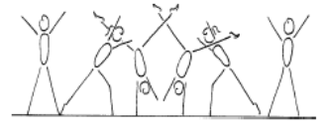 | - start in forward lunge  - good rhythm - foot, hand, hand, foot, foot  - body remains in the vertical plain  - body remains in a straight position - no arch, no pike  - head remains neutral  - small straddle during the hand support phase  - finish in a side position
 | 4. F3-3.1 Have the gymnast stand in a small straddle with their arms overhead (simulating the side handstand position), they perform a ¼ turn to the left return to the middle and ¼ turn to the right | 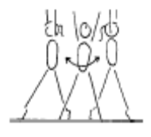 | - keep hips open and tight  - chest in  - emphasise square hips and shoulders  - emphasise the 1/4 turn action
 | 5. F3-3.2 With coach assistance perform the entry to a vertical side handstand with a small straddle, have the gymnast ¼ turn to the left and return to the middle then ¼ turn to the right and return to the middle | 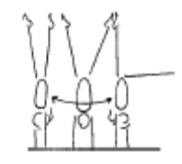 | - this drill emphasises the 1/4 turn action and square position needed to perform the cartwheel snap up and the round off  - keep hips open and tight  - chest in  - emphasise square hips and shoulders  - emphasise the 1/4 turn action  - encourage the gymnast to look towards where their foot would land
 | 6. Lying on back on floor – start in star position and turn hips/shoulders ¼ turn each way to learn ¼ turn
 | 7. Learn hand position for ¼ turn cartwheel
 | 8. Against a wall – cartwheel to stop in handstand – coach assists gymnast to ¼ turn and step down
 | 9. Cartwheel step-down from a raised surface (bench or box)
 | 10. F3-3.3 Perform the cartwheel down an incline – emphasizing the ¼ turn | 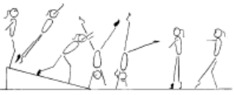 | - keep hips open and tight chest in  - emphasise square hips and shoulders throughout  - emphasise the 1/4 turn action
 | 11. ®* Cartwheel step in (snap) | 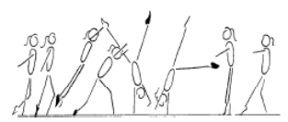 | - start with square hips and shoulders in the direction of travel  - lunge into the cartwheel maintaining square posture  - kick to a vertical side handstand with a small straddle  - first hand is placed same as a side cartwheel and becomes the support and rotational hand  - second hand is turned a 1/4 turn and placed pointing towards the first hand and becomes the repulsion hand  - head neutral  - body rotates 1/4 turn so that shoulders and hips are now square and facing the direction of travel  - head is neutral and eyes can see where the foot is about to land  - keep arms straight and chest in  - once the body is vertical over the second hand the chest lifts and the feet come down causing a ‘see-saw’ illusion  - the shoulders must not go past the vertical line  - finish in a stand with arms forward low horizontal  - chest in, hips open
 | 12. Courbettes from BB | 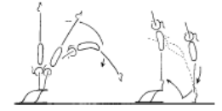 | - maintain body tension and alignment  - head neutral  - hands slightly turned in  - shoulders remain over the initial support position  - bounce from the floor
 | 13 F4-2.5 Perform a roundoff from a rebound surface to a lower landing surface – onto feet | 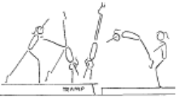 | - ensure the body remains within the vertical plain, no pike or arch action  - maintain good body tension and alignment  - repulsion from hands occurs during the vertical phase when the body is travelling upwards with the heel drive  - land in a dish shape with arms forward low horizontal

LEVEL 2 FLOOR (3)
Backward Roll (for back salto) | 1. ® © Bwd roll (tuck) to squat – straight arms |  | - Legs together  - Smooth rolling action
 | 2. Bwd roll to candlestick
 | 3. F2-4.4 Back extension roll down an incline with straight arms to a front support (then on the floor). The gymnast can start on 1 leg, a perfect rounded dish shape can then be maintained throughout the body, during the roll | 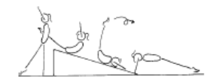 | - have arms turned in so little fingers contact the floor first  - keep arms locked  - legs together  - land in front support with toes under  - maintain body tension and alignment  - head neutral
 | 4 * Bwd roll to front support (*)
Stride Leaps | 1. F2-2.5 stride/split jumps on the trampoline (double mini)
 | 2. Step kick & hop – hold leg up – land with bent supporting leg and hold
 | 3. Landing position jumps along beam – back leg held
 | 4. Kick holds fwds & bwds
 | 5. ® © Stride Leap 135’ (Min 90’ split) | 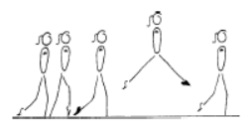 | - square hips and shoulders throughout the skill  - extended toes, ankles and knees  - legs should be level  - head up, eyes down  - arms out to the side, horizontal  - control of body
Leaps/Jumps | 1. ® © Chasse hop R, Chasse hop L |  | - Step forwards into chassé extending legs and joining feet in the air  - Hips open & chin up  - Good attitude position  - Good amplitude and extension in hops  - Chest vertical on take off, jump and landing  - 135 degree split shown in jump
 | 2. Split Jumps
 | 3. Tuck Jumps
 | 4. Wind ups
Body Wave | 1. ® © Fwd arm wave |  | - Aesthetic action
 | 2. F3-1.1 From lying on the floor have the gymnast spread their arms to the side and arch their upper body. Once this is mastered they can sit up by arching and using their hands
 | 3. F3-1.2 From stand arch the upper body and return to stand
Turns | 1. ® © Passé ½ turn on 1 foot |  | - Good passé position  - Straight supporting leg  - Turn on relevé  - Straight posture  - Turn entire body as one
 | 2. ® © Straight jump, jump ½ turn |  | - Stretched position  - Good height  - Legs together  - Quick and even rebound into the jump ½ turn
FWO, BWO & Tic Toc | 1. F2-5.4 Bridge with feet raised on a box, hold for 2 secs – kick over to stand | 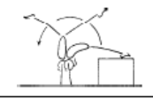 | - use shoulder and hip flexibility  - straight legs in the bridge  - straight arms throughout the skill  - pass through a vertical handstand position with legs in stride
 | 2. F2-5.5 From kneel, perform a bridge onto a high raised surface and return to stand
 | 3. Standing close to wall – gymnast walks down wall to bridge
 | 4. F2-5.5 From stand, perform a bridge onto a lower raised surface and return to stand | 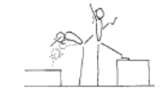 | - arms by ears with eyes looking at hands  - use shoulder and hip flexibility  - straight arms throughout the skill
 | 5. F2-5.6 Gymnast performs a handstand and the coach supports the gymnast into an arch shape
 | 6. Spotted limber down to bridge & back up again to stand
Hurdle | 1. F4-2.2 Stand in dish shape – leaning against a partner | 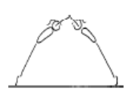 | - maintain good body tension and alignment  - chest in, hips under  - arms by ears  - head neutral
 | 2. F4-2.3 From a jump, perform a hurdle step out – lean fwd | 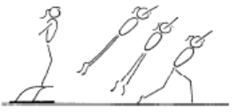 | - maintain good body tension and alignment  - chest in, hips under  - arms by ears  - generated power and forces  - head neutral
Handspring | 1. Handstand onto a box – fast snap of legs

LEVEL 2 BARS (1)
Tuck Swings /Glides | 1. B2-2.1 Tuck leg lifts on wedge x 7
 | 2. ®* From box or floor – 1 x Tuck swing 1 x glide swing, return to floor | 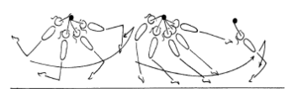 | - show a rounded body position on the jump to catch the bar, head neutral, chest rounded and hips under  - straight arms throughout the swing  - chest rounded and hips under throughout the swing  - the swing should gain amplitude  - a slight ‘tap’ action should be evident  - ‘dish’ shape at the start of the glide swing  - feet close to the floor during the glide swing  - toes swing to bar height at the peak of the ascent phase of the glide swing, hips open  - land safely at the back of the swing
 | 3. B2-2.3 Repeated tuck swing glide swing series
 | 4. ® © From box or board – Glide swing, return to floor | 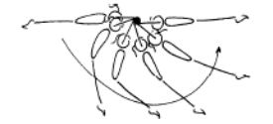 | - smooth rhythm  - good amplitude at the back and front of the swing  - maintain good body tension and alignment
 | 5. From box or board – glide swing – return to box – to encourage dish
Front Support /Casts | 1. B2-3.3 Straddle cast to rest feet on a shape – return to the bar | 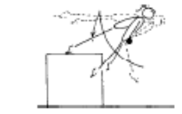 | - arms must stay straight with shoulders over the bar  - head neutral  - fast backward body snap action  - strong front support position when feet land on the shape
 | 2. Casts caught by coach to correct shape | 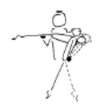 | - arms must stay straight with shoulders over the bar  - head neutral  - fast backward body snap action  - coach assists by momentarily supporting the gymnast in the ascent peak phase to check body tension, then allows the gymnast to continue  - straight body shape at the ascent peak phase
 | 3. 5 x casts in a row
 | 4. ® © 2 x Casts to 45’ below horizontal | 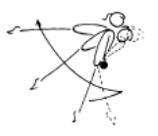 | - straight arms throughout the cast  - bring feet in front of the bar to initiate cast  - tip shoulders forward slightly  - cast feet backward and upward with a strong backward body snap  - straight body position at the ascent peak of the cast  - head neutral  - maintain good body tension and alignment during all phases of the cast  - return to the bar
Fwd Roll Dismount | 1. Hold tuck position hanging on bars – 7 secs
 | 2. Hold pike position with toes to the bar – 7 secs
3. Hold L hang (1/2 lever) - 7 secs
Begin with feet supported
 | 4. ® © Fwd roll to tuck hang, hold for 3 sec | 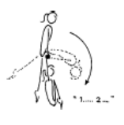 | - straight arms throughout the front support phase  - chest rounded on the bar  - tight tuck in the roll forward  - knees to chest in the tuck hold
 | 5. ®* Fwd roll to L hang – hold for 3 secs (*)
Pullover | 1. Pull to Chin up position – 5 x leg lifts
 | 2. Show inverted hang position – push/roll body over to front support
 | 3. ® © Backhip pullover to front support | 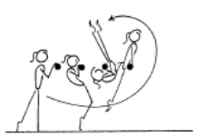 | - fast rotation around the bar  - toes and hips to the vertical line early  - keep head neutral  - move wrists around the bar quickly  - maintain good body tension and alignment  - finish in good front support
 | 4. Pullover to feet on box

LEVEL 2 BARS (2)
Back Hip circle | 1. B3-1.3 From front support, perform a ‘tip upside down’ maintaining a straight body, then finish the 2nd half of the circle still maintaining a straight body with coach assistance | 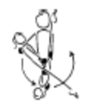 | - head neutral  - maintain good body tension and alignment  - fast wrist action on completion of circle
 | 2. B3-1.3 From front support perform a fast ‘tip around’ with coach assistance |  | - head neutral  - maintain good body tension and alignment  - fast wrist action on completion of circle
 | 3. B3-1.1 Cast to invert, run up the hill (using a wedge shape tied to the bar) | 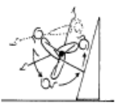 | - minimum cast of 45’  - drop shoulders back fast  - bring hips and feet under the bar fast  - place feet on the shape and run up the hill and pullover  - fast wrist action on completion of circle  - complete circle by finishing in strong front support position
 | 4. ®* Cast, backward hip circle | 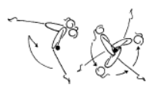 | - maintain good body tension and alignment  - arms straight  - head neutral  - after the cast the shoulders move backward whilst the feet move down, forward then upward  - push chest back  - rotation should be even and smooth  - wrists move quickly on completion of the circle  - finish in front support
Toe Shoot Dismount | 1. B3-2.2 From a low box, place one foot on the bar, then jump the 2nd foot to straddle position and swing – stay in straddle position | 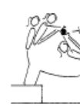 | - ensure good closure  - balls of the toes on the bar  - release near horizontal
 | 2. B3-2.2 Jump from the floor to feet on the bar in a straddle pike swing, on the 3rd swing release and dismount to land | 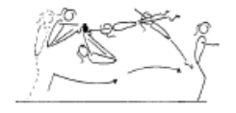 | - ensure good closure  - balls of the toes on the bar  - release near horizontal
Cast to Squat | 1. B4-2.2 Stoop, straddle and squat onto several different shapes around the gym (eg beam, low box), stand and jump off
Long Swings & Long Swing Pullover | 1. B2-4.2 From a straight hang on the bar the gymnast performs tap swings, the coach can spot the gymnast by placing their hands on the gymnasts stomach and back initiating and supporting the tap swing | 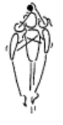 | - the coach can remind the gymnast of the Key Points  - a strong rhythm must be visible  - gymnast must feel a good rhythm  - maintain good body tension and alignment
 | 2. B3-4.1 From standing on the low bar, start in dish position, swing through into an arch swing fwd and return through arch and stand on the bar in a dish shape | 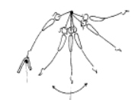 | - ensure a good understanding of the key shapes  - evident power generated from strong tap forward and backward  - maintain good body tension and alignment
 | 3. B4-5.1 Chin up pullovers x 5
Kickstart | 1. 5 x Leg Lifts on high bar – straight legs
 | 2. Holding toes to the bar in a pike position – shoot toes to roof (assisted) x 5
 | 3. On high bar, raise toes up to bar, bounce down to arch
Kips | 1. B3-6.2 Box kip, start with box under the bar, gymnast moves the box fwd as they improve | 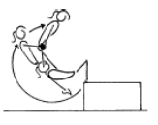 | - arms straight throughout the skill  - fast jump  - fast wrist action  - closed front support position on completion
 | 2. B4-3.1 – Simulate kip action with broom stick, lying on back | 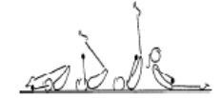 | - emphasise full stretch before bringing feet to the bar  - straight arms throughout  - shoulders forward over bar  - feet finish in front of bar - closed pike shape  - head neutral
 | 3. Using bungee cord tied to ladder – begin holding bungee high above head with straight arms – pull bungee cord quickly towards thighs
 | 4. B4-3.4 – From front support – coach spots drop to hanging pike position
 | 5. B4-3.4 From hanging pike position – coach spots gymnast to ‘shoot’ toes to the roof – repeat x 5
 | 6. Teddy throws – gliding with teddy between feet – snap feet to bar trying to throw the teddy over the bar
 | 7. Straddle leg lifts – hanging on a high bar. Show star, rotate hips under through straddle position and up to touch bar x 5

LEVEL 2 BEAM (1)
Front support Mount | 1. M1-1.5 From stride support, swing legs to front support, or high pike position | 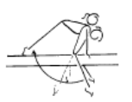 | - maintain good body tension and alignment  - arms straight  - shoulders will be slightly in front on hands during the back swing  - keep torso clear of the Beam
Kneeling Scale | 1. ® © Jump to front support, swing leg over to straddle sit, swing back to kneeling scale | 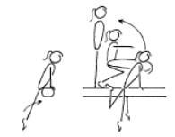 | - straight arms in front support  - legs straight during the first phase  - during the swing to squat, or lift feet behind, keep arms straight and head neutral  - in the squat have shoulders upright and weight on the balls of the feet
Squat On Mount | 1. M3-1.2 Squat on the end or side of a high bench/low beam with no hands (hands release as soon as feet touch) | 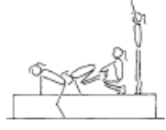 | - keep shoulders upright  - squat on toes  - keep hips and shoulders square
Arabesque /Posture | 1. ®* Arabesque (back leg min 90’, held 2 sec)
Attitude Steps | 1. ® © 2 x Attitude steps R & L (extend leg to horizontal after each attitude) | 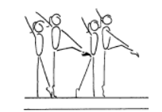 | - one arm moves to low oblique to touch the top of the opposite knee, the other arm repeats the same pattern  - support leg is straight  - the free leg is turned out and the knee is lifted to hip height – then extended to horizontal after each attitude  - steps are to be performed on toes  - hips under, stomach pulled in  - head up, eyes down  - good rhythm  - stable balance
Releve/Turns | 1. Right/Left pivot walks (side passé to fwd passé – develop, point, step weight transfer
 | 2. ® © Side & Fwd Passe, legs together ½ turn on 2 feet |  | - Show passé positions  - Turn in relevé  - Straight posture  - Turn entire body as one
 | 3. M1-7.3 On floor, learn side passé, fwd passé, releve ½ turn on 1 foot – land in fwd passé position and hold
Locomotion | 1. 4 x steps in releve (on toes) | 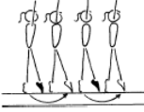 | - arms position optional  - legs straight  - steps are to be performed on toes with legs slightly turned out  - heels pushed forward into a high arch shape  - hips under, stomach pulled in  - head up, eyes down  - good rhythm  - good balance
 | 2. M2-3 Chasse along bench/low beam | 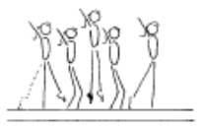 | - good rhythm  - confidence  - good body alignment and control  - extended toes, ankles, knees and hips
 | 3. Step Kicks | 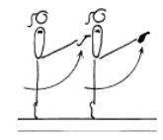 | - good rhythm  - good posture  - free leg lifted to hip height minimum  - arms are horizontal  - kicks performed on toes if possible  - support leg locked out
Jumps /Leaps | 1. Straight Jump | 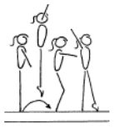 | - ensure efficient use of arms  - ensure shoulders upright at all times  - knee bend should not exceed 45’  - heels pushed forward into a high arch position  - hips under and stomach pulled in  - head up and eyes down  - emphasise square hips and shoulders during take  - off and landing
 | 2. ® © Straight jump with foot change |  | - Stretched position  - Good height  - Legs together

LEVEL 2 BEAM (2)
Stride Leap | 1. ® © 2 x High fwd kicks |  | - good rhythm  - good posture  - free leg lifted to hip height minimum  - arms are horizontal  - kicks performed on toes if possible  - support leg locked out
 | 2. Step kick & hop – hold leg up – land with bent supporting leg and hold
 | 3. Landing position jumps along beam – back leg held
 | 4. ®* 2 x step hops with straight leg – R&L
 | 5. M3-2.4 perform 2 x leap progressions on a on a bench with light mat over
 | 6. Stride jumps on bench/low beam
Body Wave | 1. M2-4.2 Perform contraction and arch x 4 then finish with contraction to stand, repeat starting with arch. Present arms on completion | 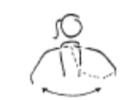 | - do not cross arms in front of body  - the arms are led by the elbows  - when arms are forward body should be contracted and knees slightly bent  - when arms are back body should be arched, knees locked, bottom tight  - when arms hit vertical, horizontal and down the head and wrists should flick
Handstand | 1. M1-3.1 Scorpion on beam
 | 2. © M3-4.2 Perform a 90’ handstand on a line / low bench | 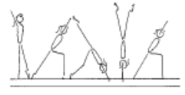 | - shoulders and hips square  - hips under, chest in  - head neutral  - one leg vertical, lunge leg at 90’  - finish in a lunge
 | 3. ®* “L” Handstand
 | 4. M3-4.3 Perform a 90’ handstand on a high bean (with coach assistance) | 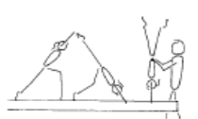 | - shoulders and hips square  - hips under, chest in  - head neutral  - one leg vertical, lunge leg at 90’  - finish in a lunge
Straight Jump Dismount | 1. ® © ¼ turn – straight jump dismount |  | - Stretched position  - Two feet take off  - Good amplitude in jump, feet higher than beam  - Controlled landing
Punch Set D/Mt | 1. M4-2.2 Perform the 2-3 running steps on a low beam, punch up onto a raised surface

LEVEL 2 VAULT (1)
Bounce /Spring | 1. Ankle raises x 20 with both feet then 15 on each leg
 | 2. V1-5 Springing Circuit – variety of 8 objects | 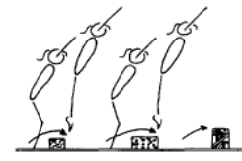 | - maintain good body tension and alignment  - continuous bouncing, no pauses or stops  - easy clearance of the objects
 | 3. V1-4.3 Cross arm skipping x 10
Running | 1. V3-3.2 Running with high knees | 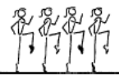 | - head neutral  - extend through ankles and toes  - lift knees to hip height with a fast powerful action  - arms in line with body
 | 2. Running “kicking bottom” with feet (pointed toes)
 | 3. Resistance Running – with bungee cord | 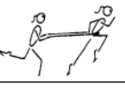 | - lift knees  - lean forward  - head neutral
 | 4. V3-3.1 Bounders – the ideal position/action can also be practice on the floor or hanging from something | 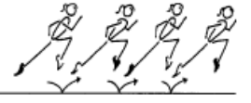 | - head neutral  - lift the knee high at the front  - lift the leg high at the back with minimal bend  - arms in line with body
Hurdles | 1. Step hurdle punch to 8’ mat – correct arms
 | 2. V1-3.1 Perform hurdle from the edge of a 30cm box – to a board, up to a 30 or 60cm box – using correct arms | 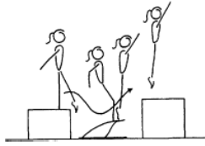 | - underarm action  - fast explosive bounce  - arms stop at 45’  - maintain good body tension and alignment
Straight Jump Vault | 1. Short run, hurdle with arm circle, 2 feet take off, straight jump from spring board to 60cm crashmat or box
Handstand Flatback | 1. V2-1.2 Handstand on a board with assistance from the coach, gymnast performs shoulder shrugs | 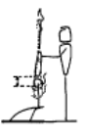 | - head neutral  - maintain good body tension and alignment
 | 2. Fast “snapped handstand to padded wall
 | 3. Lying on back on crashmat – coach lifts gymnasts body (must stay straight) and lets go – body should go “BANG” to ground not “KER PLOP”
 | 4. Standing on beatboard with back to crashmat – gymnast falls backwards to land on crashmat. Should land with a “BANG” – not with a “KER PLOP”
 | 5. ® © Step kick to handstand on board, fall to flatback on 30cm crashmat | 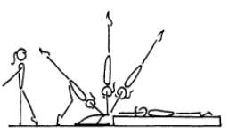 | - underarm action  - strong handstand position  - shoulders remain open during fall  - head neutral  - land in tight straight body position, hips and shoulders open
Handstand Pop | 1. V3-4.1 hold a stretched front support (prone position) | 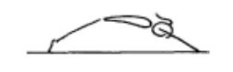 | - head neutral  - maintain good body tension and alignment

LEVEL 2 VAULT (2)
Catsprings -Handspring Vault | 1. V2-2.4 Seal walks | 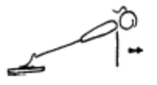 | - rounded back  - hips under  - arms straight  - head neutral
 | 2. Clap pushups on floor
 | 3. Jump to 45’ handstand over object
 | 4. Fast kicks to handstand with legs “snapping” onto padded wall
 | 5. Straddle on to 3’ box, jump off to SLP
 | 6. V2-2.5 Cat Springs on a rebound surface (double mini) | 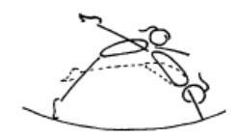 | - dynamic action  - open hips  - good heel lift (backward body snap)  - maintain good body tension and alignment
 | 7. ®* Short run, handspring from board to land flatback on 60cm crashmat (hands on mat) | 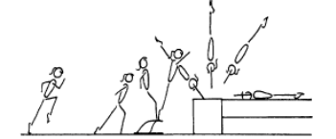 | - fast run  - low hurdle  - underarm action  - repulsion is instantaneous  - dynamic  - fast heel drive (backward body snap)  - hands contact vault early during the upward phase  - maximise air time in after flight  - good body tension throughout - legs straight and together, arms straight, head neutral
Dive Roll / Front Salto | 1. From a run, straight jump onto 60cm mat with straight legs and chest snap | 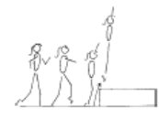 | - stretch tall on take off, vertical take off  - maintain body tension and alignment  - head neutral
 | 2. V3-2.3 From a box dive roll over a small object onto one supersoft mat (no run)
 | 3. V3-2.4 From stand on a 60cm box, dive roll from a mini-tramp onto 2 or 3 supersoft mats (no run)
 | 4. V4-1.6 From stand on the floor, jump fast fwd roll up onto 1 supersoft mat, then 2 supersoft mats

